Wide Area Network
Q1. Draw a simple diagram (on paper or using an online tool like draw.io) showing how your phone connects to Instagram's servers from your home WiFi, including the ISP and at least two Wide Area Network (WAN) devices (like routers or switches) in the path.
Ans:
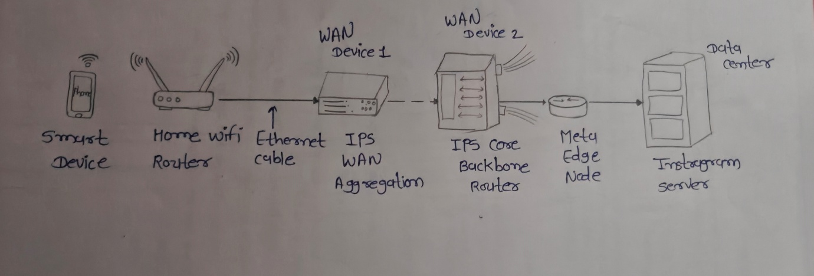
Figure 1: Phone Connection to Instagram via Home Wi-Fi, ISP, and WAN Devices
Explanation:
When I open Instagram on my smartphone, the request is first sent to my Home Wi-Fi Router. The router forwards the request to the Internet Service Provider (ISP). The data then passes through WAN Device 1 and WAN Device 2 before reaching Instagram's servers. After processing the request, the server sends the response back through the same path to my phone.
Q2. Create a table listing three types of WAN technologies (such as MPLS, Leased Line, and Broadband Internet) and compare them based on speed, cost, and where you might see them used in real life (e.g., Zomato office, IRCTC ticketing, your home).
Ans:
WAN Technology | Speed | Cost | Real-Life Use
MPLS (Multiprotocol Label Switching) | High and reliable | High | Used by large organizations such as Zomato offices, banks, and corporate branches for secure communication between offices.
Leased Line | Very High (Dedicated Connection) | Very High | Used by IRCTC ticketing systems, data centers, hospitals, and large companies that require a dedicated and uninterrupted Internet connection.
Broadband Internet | Medium to High (depends on ISP and plan) | Low to Medium | Used in homes, small offices, schools, and shops for everyday Internet access such as browsing, streaming, online classes, and video calls.

Q3.Research and write a short explanation of how a VPN (Virtual Private Network) uses WANs to let you access apps like Spotify or YouTube securely from a public WiFi at a coffee shop.<br><br><em><strong>Hint:</strong> Focus on how the VPN creates a private tunnel over the public WAN.</em>
Ans:
How a VPN Uses WAN to Secure Internet Access on Public Wi-Fi:
A VPN (Virtual Private Network) creates a secure and encrypted tunnel between a user's device and a VPN server over the public WAN (Internet).
For example, if I connect my laptop or phone to the free Wi-Fi at a coffee shop and open Spotify or YouTube, other people on the same public Wi-Fi may try to intercept my internet traffic. If I first connect to a VPN, all my internet data is encrypted before it leaves my device.
The encrypted data travels through the WAN (Internet) to the VPN server. The VPN server then forwards my request securely to Spotify or YouTube. The response comes back to the VPN server and is encrypted again before reaching my device.
Because of this encrypted tunnel:
- My personal data remains secure.
- Hackers on public Wi-Fi cannot easily read my internet traffic.
- My real IP address is hidden from the websites I visit.
- I can safely use online services even on unsecured public networks.

Real-Life Example
Scenario: Using Spotify at a Coffee Shop
- Connect to the coffee shop's public Wi-Fi.
- Turn on the VPN application.
- The VPN creates an encrypted tunnel over the Internet (WAN).
- Open Spotify.
- The request goes:
Phone → Coffee Shop Wi-Fi → Internet (WAN) → VPN Server → Spotify Server
- Spotify sends the response back through the VPN tunnel to the phone.
This keeps the communication private and secure even though the Wi-Fi network is public.

Q4. Imagine Flipkart wants to connect its warehouses in Ahmedabad, Mumbai, and Delhi. Suggest which WAN technology would be best for them and justify your answer with two reasons.
Ans:
Best WAN Technology: MPLS (Multiprotocol Label Switching)
Explanation:
If Flipkart wants to connect its warehouses in Ahmedabad, Mumbai, and Delhi, the best WAN technology is MPLS.
Reasons:
- Reliable and Fast Communication
  - MPLS provides a dedicated and stable connection between all warehouses.
  - This helps employees access inventory, orders, and warehouse data quickly with low delay.
- Secure Data Transfer
  - Customer orders, payment details, and inventory information are transferred securely.
  - MPLS is more secure and reliable than using the public Internet for business communication.

